Promotion process guide for staff members
This guide is developed for staff members to get familiar with the Promotion process and more specifically what steps they must take for promotion.

Pre-promotion steps

Deciding to start the process
When you feel you are ready for a promotion, the first person to talk to is your manager. They will take note of your ambition and will inform and support you in the next steps to take.

Determining if you are ready
You, together with your golden triangle, will look at your current level of soft and hard skills and compare them to the seniority guidelines staff. You gather extra feedback from internal and external (if applicable) colleagues to get a better understanding of your current level, which will also help you to develop further. The outcome of these steps will determine what happens next:

- After confirming, within the Golden Triangle, that you are at the desired seniority level, proceed to Step 3.
- The outcome is that you are not on the desired level yet.
Action: Together with your golden triangle you set goals and work towards the desired outcome. Depending on your current level, this part of the process can differ in time (week or months).

It is advised to proceed with the next step when you and your golden triangle are aligned you have reached the overall desired seniority level. However, the initiation is up to you.

Promotion steps

Create a reflection report
Create a promotion reflection report in TruQu, focusing on the journey you took to get to your desired level. A template for this report can be found in TruQu with more info on this. See the manual on how to find this below.

Request a promotion meeting
Send the TruQu reflection report in an email to your Manager and your Golden Triangle in the cc. Your manager will take care of the next steps.

Next steps
No more concrete action is required from now on. You will be informed of the planning by your manager. Your manager will gather feedback from your peers and after discussion within the MT (promotion meeting) they will make a decision based on all the input. The FAQ will provide answers on who is on this committee and what is input for the decision. The decision will be communicated back to you:
- When promoted: Congratulations! If you agree, your promotion will be shared during the business update and the salary mutation will take effect the next month after the decision has been made.
- When promotion postponed: You will get concrete development steps and focus points from your manager to work on with your Golden Triangle. You will also be advised when to try again. Do not give up!

FAQ

What is the timeline of the process?

Standard Process
Week 1 starts when reflection report is received
Week 1-3 your manager will retrieve feedback
Week 4 promotion meeting scheduled no later than this week
Weeks 4 or 5 communicate decision to staff member on promotion

Delayed Process (optional)
Week 5-6 delay to gather additional feedback (staff member will be informed)
Week 6 second promotion meeting
Week 6 communicate decision to staff member

Who is in the promotion meeting and what is their role?
The promotion meeting consists of:
- Your manager gathers feedback
- The other managers: assist in the process and provide consistency

What input will be used for my promotion?
- The main input will be the feedback gathered from your peers by the manager. Peers are preferably colleagues/consultants from Digital Power but can also be external contacts, for example the hiring managers for our commercial team members.
- The contents of your reflection report.

How should I use feedback in my reflection report?
You can choose to add quotes or feedback forms to your reflection report to support your case. Feedback is used for your own development, so it is not expected that you will add this feedback to your reflection report. Your manager will gather feedback that will be used for decision making.

What if I have not been able to develop myself properly due to non-challenging work/projects?
You have regular updates with your manager where you talk about your development. If you are not happy with your tasks, you act together on this. For example, spot new opportunities, scale down some tasks or ask help from other staff members.

What if there are no peers available to give feedback at Digital Power or externally?
Your manager will always take your skill level into consideration. In the exceptional scenario where peers from neither Digital Power nor external are available, there is a third option. You will provide samples of your work, and you will sit down with your manager to determine your skill level, like an informal interview. Keep in mind, this will only take place as a last resort.

Manual reflection report
Manual for finding and writing a reflection on your promotion.
The reflection template can be found in TruQu. The questions are only available in English, but you can write the report in Dutch if you prefer to do so.
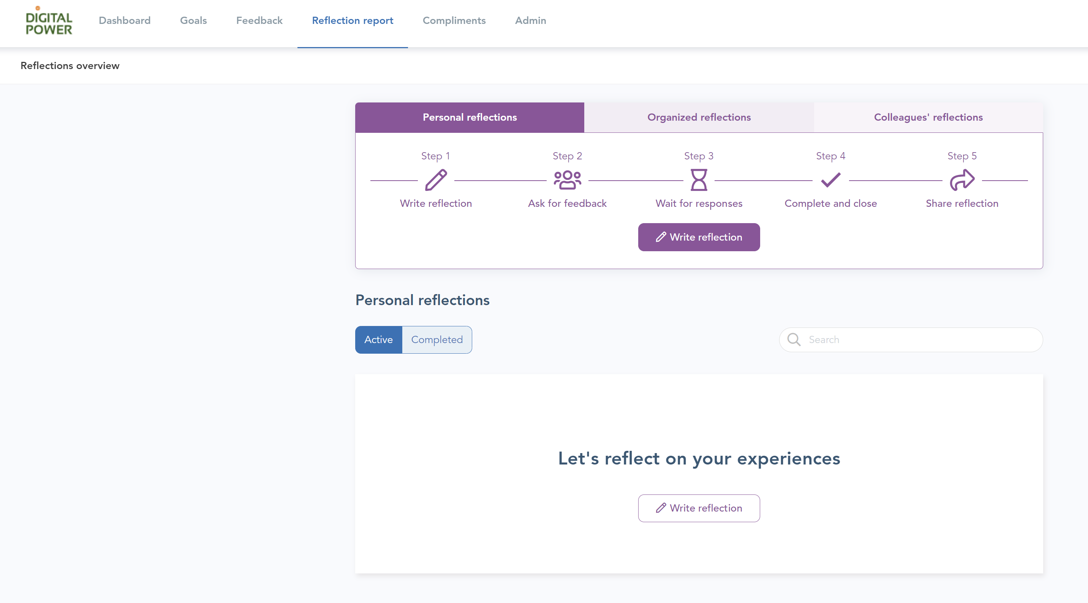

Start your personal reflection. Give your reflection a title and select a period that you want to include in this reflection.
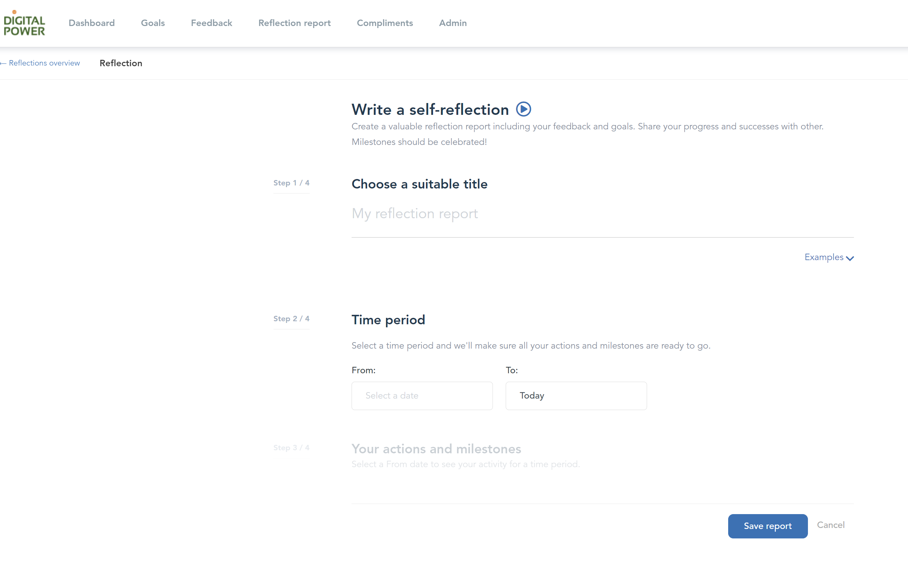

In TruQu, it is possible to add specific actions and milestones to this reflection. You can do so if you want, but it is not needed for your promotion reflection. You can also add people you have received feedback from, this is also optional.
You are now ready to start with the reflection. There is a list of templates available, choose the option: reflection for the next step in seniority (promotion).
You will then be presented with a series of questions that help you build your case for the promotion committee.

